Sherbet Lemon Theatre
The Truth About Bedtime… Technical Rider

Company: Sherbet Lemon Theatre
Show: The Truth About Bedtime…
Tech Date: 15/05/2018 2-6pm
Show Date: 21/05/2018

Firstly, thank you for allowing us to perform at your venue. Here is a document of our technical requirements. If anything is unclear or you have any questions, please do not hesitate to contact our Stage Manager, Chloe McKay, who can be reached on sherbetlemontheatre@outlook.com.

MINIMUM STAGE AREA:
7.115m height
6m length
8m width
The staging for The Truth About Bedtime… is to be intimate. Therefore, the space would work best if the floor can be levelled out to meet the stage, removing all stalls level seating. Members of Sherbet Lemon Theatre are more than happy to assist in this process. We would then require 80 individual chairs for our audience.
SET:
The staging for The Truth About Bedtime… is horseshoe. Our set consists of four parasol poles, four plastic bases for the poles, one sheet, fairy lights, four dream catchers, a large light up alarm clock, plastic washing basket, blankets and pillows UCS. Please see the pictures at the end of this document for reference.
We will require:
- 2 stage weights
- Minimum 80 chairs (for audience members)
- 2 chairs for performers
- Material to hold balloons or confetti to fall from grid. We will provide the balloons or confetti (subject to availability)

LIGHTING:
We will require:
- Minimum of 1 boom
- Minimum of 2 profile (one to be located behind the sheet to give the effect of a light bulb, see picture below of set)
- Minimum of 1 UV canon
- Minimum of 2 LED par’s
- Minimum of 2 Fresnel’s
- Access to Mirror Ball
- Access to in house lighting desk
We will provide:
- Minimum of 4 sets of fairy lights
- 1 nightlight projector

SOUND:
We will require:
- 1 SM58 Wireless Microphone
- 1 Microphone Boom Stand
- Access to in house sound desk / speaker system
We will provide:
- 1 guitar
- 1 ukulele
- 1 amp
- 1 Macbook Air with access to QLAB 3

PICTURES OF SET:
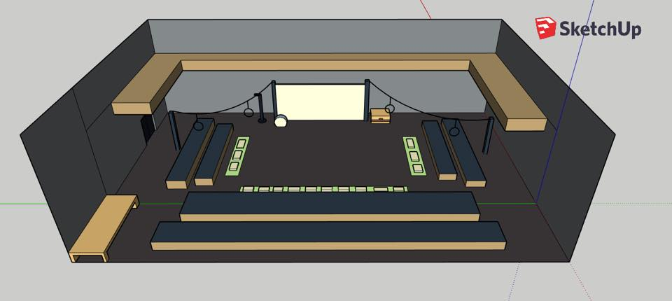
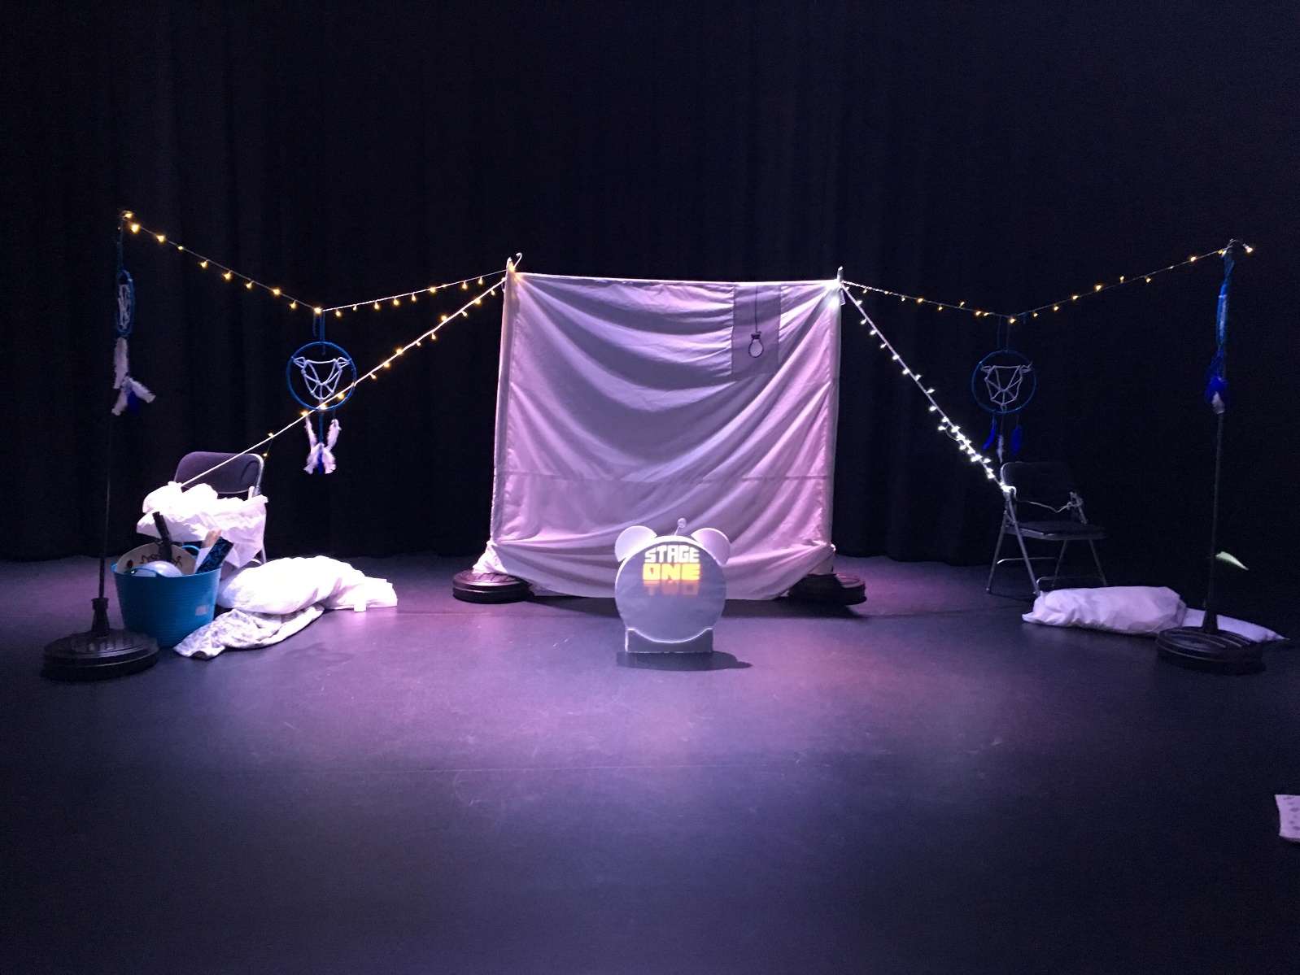

*the chairs either side of the sheet indicate where the stage weights we require will be*

