Sherbet Lemon Theatre
The Truth About Bedtime…
Stage Manager: Chloe McKay
Tech Designer: Chloe Denby
Lighting Plot

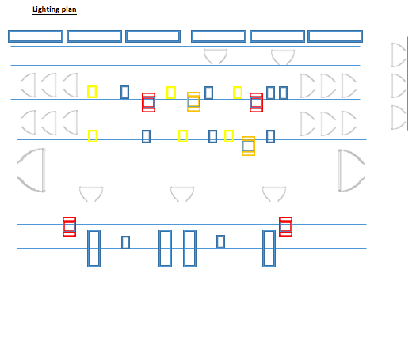

- LED PAR

- WARM FRESNAL

- COLD FRESNAL

- BATTERN

- SR TOP/MID/BOTTOM

- ROGUES

- QWASH/ QWASH 419

- PROFILE

NOTE: We also use a profile behind the sheet on stage, however this is on stage.

